## Display Tracking Information or Download Batch file (Diagram 1.1 Version 1.0 11/24/2015):

: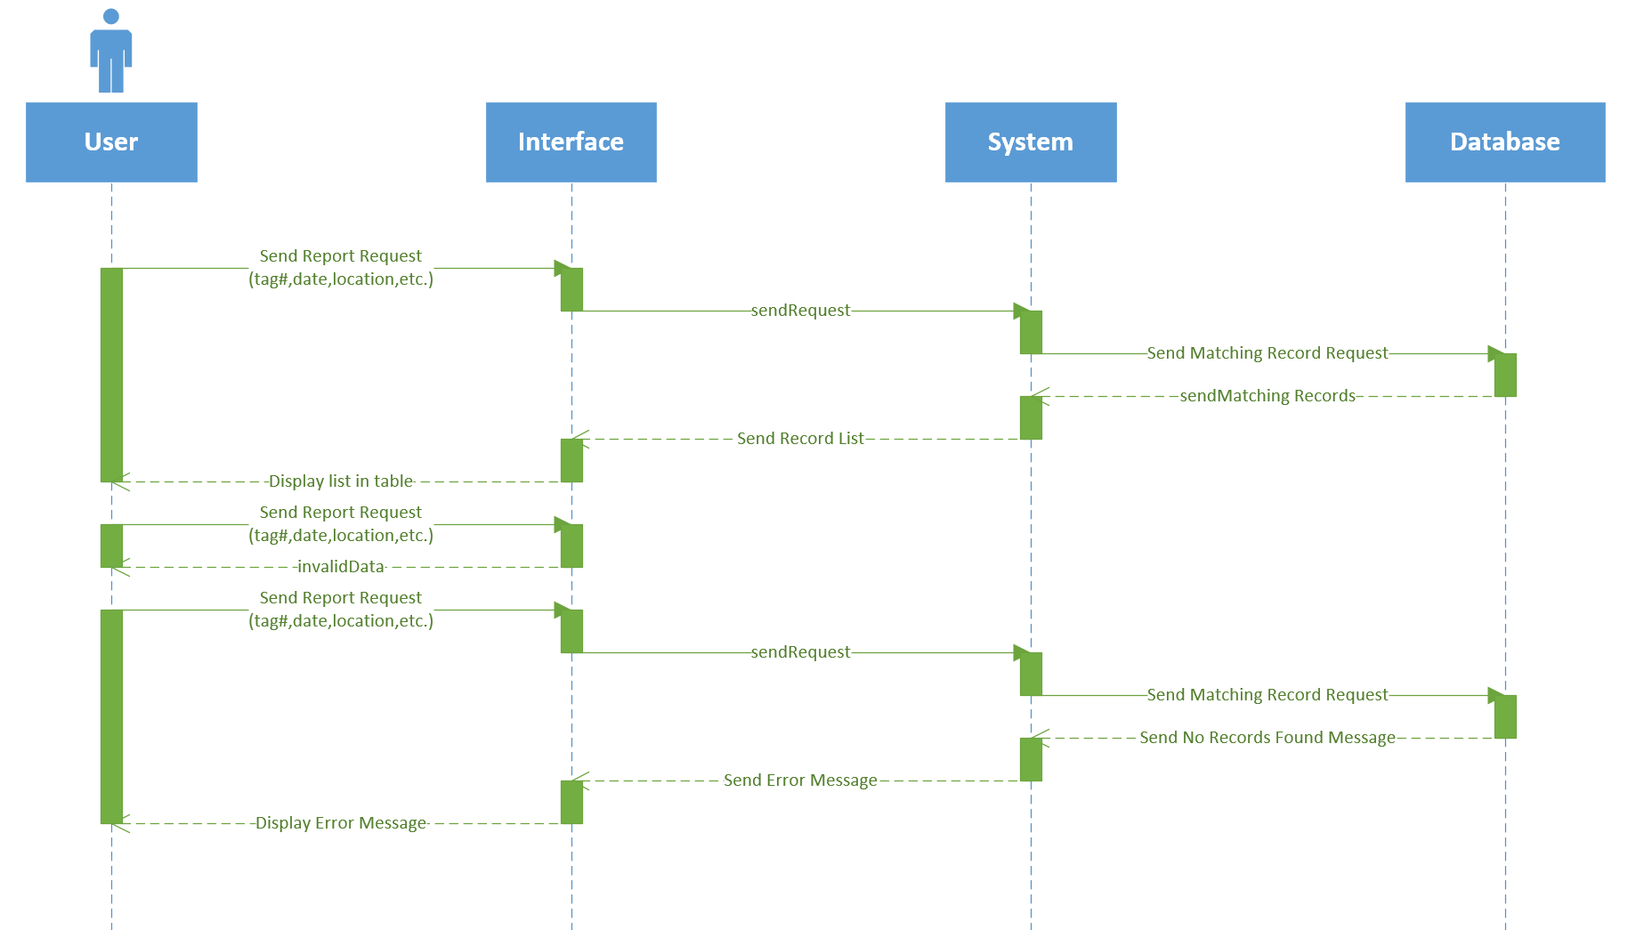

## Custom Region Sightings (Diagram 1.2 Version 1.0 11/24/2015):

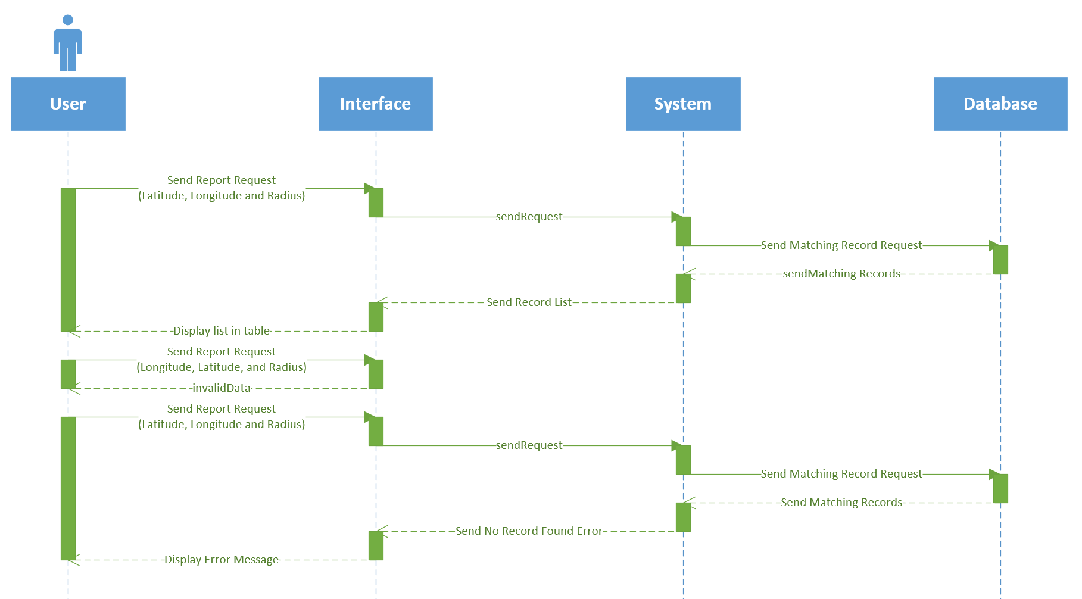

## Butterfly Migration Route (Diagram 1.3 Version 1.0 11/24/2015):

